Web Network Load Balancer
Methodology and Work Plan

Version 1.0



Supervisor Name: Tanweer Arshad
Student Name: Faheemullah Memon
Student ID: MC070402736

Revision History

Date (dd/mm/yyyy) | Version | Description | Author
25/11/2012 | 0.1 | Initial draft | Mc070402736
26/11/2012 | 1.0 | Finished and reviewed | Mc070402736

Table of Contents
Revision History 2
1. Introduction of the Planning Phase 4
1.1. In this document 4
2. Methodologies 5
2.1 Existing Methodologies 5
2.2.1. Waterfall 5
2.2.2. Prototyping 6
2.2.3. Spiral and/or Iterative 7
2.2 Adopted Methodology 7
2.3 Reasons for choosing the Methodology 7
3. Work Plan (Use MS Project to create Schedule/Work Plan) 8
3.1 Work Plan in Image Format 9

1. Introduction of the Planning Phase
Like any other project either technical or non-technical, a software project development also starts with planning phase. Planning phase follows the requirements gathering phase; once requirements are defined and inked to the paper eloquently a development plan needs to be developed.

Software development plan predominantly includes a time frame and budgeting details. It answers an important question of how long would it take to complete and deliver the given project with resources available. By all means it addresses the so-called Iron Triangle of project management. With project scope locked down in requirements documentation, we tackle cost and schedule for the development of software.

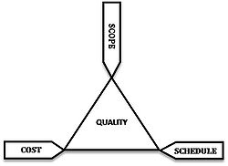
The Project Management Triangle (Iron Triangle)

A software project’s quality, cost, and schedule are all affected by the development methodology adopted. Right methodology can go a long way in the life of the software projects.

1.1. In this document
This document is divided into two parts. First part goes over the software development methodology used to develop the Web Network Load Balancer software and then it expands on the development schedule.

2. Methodologies

2.1 Existing Methodologies
Software development methodology is intimately integrated with the quality, schedule, and cost of the development. A good software development methodology can reduce risk of scope-creep, increase work and progress visibility to the stakeholders, enable change management, and help synchronize development team and bring them on the same page. These are just a few benefits and it can really go a long way in the life of a project and has huge impact.

There are quite a few development methodologies available today and new ones are being developed every now and then focused to help maximize output of the development team given the constraints they are facing.

2.2.1. Waterfall
Borrowed from other engineering disciplines, this is the oldest software development methodology available to software teams. It follows the top-down approach and works in a ladder fashion – hence the name. Development is divided into the major steps/milestones and when you complete one step or achieve one milestone you move down to the next. It’s a pretty linear process. Project is completed when all the steps are completed.

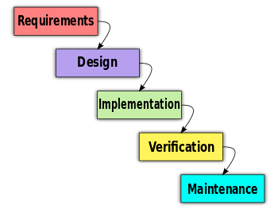
There are several problems with the model, especially not being an intrinsic model to software engineering discipline. Software engineering is a different beast than other forms of engineering. Software, although as complex any other engineering output, if done right, can be rather easier to change. This basic fact does not sit well with water fall style of development which follows the rigid framework. It’s made even worse by immature list of requirements compiled. Immature because requirements tend to change either during the project development process or after when the product is finished. It’s partly because of the unchartered territory of possibilities in software world and then because incomplete or flawed understanding of the requirements itself.

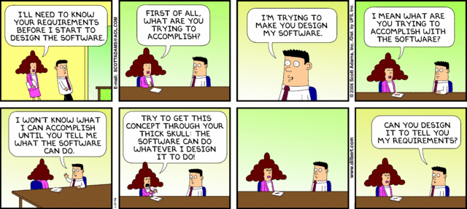
Dilbert comic strip on software requirements - (http://dilbert.com/strips/comic/2006-01-29/)

Fact of the matter is upgrading from a manual system to software system is a huge step. Then the possibilities are often beyond understanding of stakeholders about what could really be achieved with the software and these things are often not clear until after the software is developed in some shape or form.

And then because of it’s a rigid nature with closed loops and very little change management; stakeholders are only able to see the software when it’s almost finished. It becomes really hard to deviate an inch from the requirements. As pointed out before, this is against the very nature of underlined discipline; after all it’s SOFT-ware and not HARD-ware.

2.2.2. Prototyping
Prototype is described as a mock of actual software project or one of its components that looks like real software but instead is just a placeholder – a fake look alike so to speak. It provides the fundamental interaction and requirement model. Prototyping refers to the method of developing prototypes of software system or core parts of it and then keep improving those with the feedback from stakeholders. It eases off the change management by involving customers through every prototype. The next prototype accommodates any changes asked by the customer. Unfortunately, although being potent, prototyping has potential to end-up as being rather expensive. A lot of throwaway prototypes can add up to the cost and decrease development morale.

2.2.3. Spiral and/or Iterative

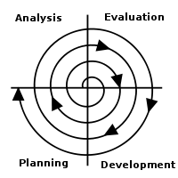

Spiral and Iterative software development methodologies are very similar. These, often called agile methodologies with some variations, are ingenious to software development. These allow maximum change management and feedback integration in the software development. This, in a way, is a combination of both waterfall and prototyping methodologies. Software development is divided into the iterations. A mini waterfall method is followed in all iterations. Requirements are locked down for the part of software being developed in the iteration, steps are followed, and once done, stakeholders are brought in to look at the part and provide feedback. Feedbacks, along with the requirements for next part, are taken back to the lab for next iteration. This methodology is not foolproof either but has proved to be more resourceful then other.
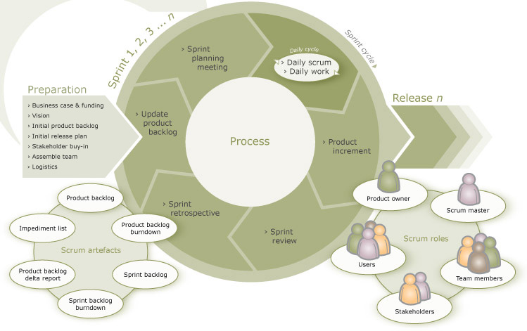
This is the process diagram for Scrum. Scrum is an Agile process framework that allows organizations to continuously direct the project toward early delivery of real business value through the frequent and regular delivery of high quality software.

2.2 Adopted Methodology
Virtual University has also defined a development model based on iterative approach, which can really be thought of as a hybrid between the waterfall and spiral models. The model is a cousin of any modern day agile software development methodology. This method, like other iterative methods, decreases the rigidity of waterfall by breaking it into smaller iterations and increases the changeability thus reducing risk of gold-platted software.

2.3 Reasons for choosing the Methodology
As explained in previous sections, a right mix of waterfall, prototyping, and spiral – the VU process model as we call it - extracts more value and decreases the risks of over-budgeting and scope-creep at the same time. In essence it follows the agile manifesto and is most resourceful then the farmer options alone.

- Individuals and interactions over processes and tools
- Working software over comprehensive documentation
- Customer collaboration over contract negotiation
- Responding to change over following a plan

3. Work Plan (Use MS Project to create Schedule/Work Plan)

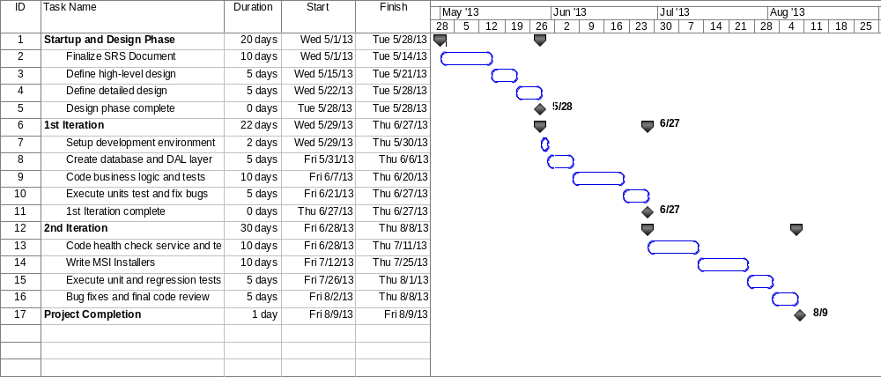

3.1 Work Plan in Image Format
